Supplementary material

Supplementary Table 1. Shapiro-Wilk normality test results for all continuous variables.
Variable | Group | N | Mean | SD | Median | IQR | Shapiro-W | p-value | Normal
Pain_Worst | BMS | 50 | 6 | 2.16 | 6 | 4.0–8.0 | 0.9331 | 0.0073 | No
Pain_Worst | OLP | 46 | 4.3 | 3.14 | 3 | 2.0–7.0 | 0.9204 | 0.0039 | No
Pain_Least | BMS | 50 | 2.3 | 1.54 | 2 | 1.0–3.0 | 0.8951 | 0.0003 | No
Pain_Least | OLP | 46 | 0.96 | 1.07 | 1 | 0.0–2.0 | 0.7927 | <0.0010 | No
Pain_Average | BMS | 50 | 4.32 | 1.7 | 4 | 3.0–5.0 | 0.9084 | 0.0009 | No
Pain_Average | OLP | 46 | 2.83 | 2.06 | 2.5 | 1.2–4.0 | 0.9171 | 0.003 | No
Pain_Current | BMS | 50 | 3.7 | 2.11 | 3 | 2.0–5.0 | 0.9318 | 0.0065 | No
Pain_Current | OLP | 46 | 1.41 | 1.59 | 1 | 0.0–2.0 | 0.8256 | <0.0010 | No
Interference_Activity | BMS | 50 | 2.46 | 2.62 | 2 | 0.0–4.0 | 0.8563 | <0.0010 | No
Interference_Activity | OLP | 46 | 2.65 | 3.26 | 1 | 0.0–5.0 | 0.7832 | <0.0010 | No
Interference_Mood | BMS | 50 | 5.64 | 2.17 | 5.5 | 4.0–7.0 | 0.9687 | 0.2057 | Yes
Interference_Mood | OLP | 46 | 5.07 | 3.48 | 5 | 2.0–8.0 | 0.9017 | 0.0009 | No
Interference_Mastication | BMS | 50 | 1.66 | 2.49 | 0.5 | 0.0–3.0 | 0.7149 | <0.0010 | No
Interference_Mastication | OLP | 46 | 3.78 | 3.25 | 3.5 | 0.0–7.0 | 0.8929 | 0.0005 | No
Interference_Work | BMS | 50 | 2.08 | 2.06 | 2 | 0.0–3.0 | 0.8637 | <0.0010 | No
Interference_Work | OLP | 46 | 2.63 | 3.12 | 1 | 0.0–5.0 | 0.8097 | <0.0010 | No
Interference_Relation | BMS | 50 | 2.62 | 2.34 | 2 | 1.0–4.0 | 0.901 | 0.0005 | No
Interference_Relation | OLP | 46 | 3.22 | 3.33 | 2.5 | 0.0–5.8 | 0.8409 | <0.0010 | No
Interference_Sleep | BMS | 50 | 2.58 | 3.15 | 1 | 0.0–4.5 | 0.7816 | <0.0010 | No
Interference_Sleep | OLP | 46 | 1.89 | 3.07 | 0 | 0.0–3.0 | 0.6689 | <0.0010 | No
Interference_Enjoyment | BMS | 50 | 4.98 | 2.54 | 5 | 3.0–7.0 | 0.9617 | 0.1042 | Yes
Interference_Enjoyment | OLP | 46 | 4.35 | 3.48 | 4 | 1.0–8.0 | 0.8934 | 0.0005 | No
Normality was assessed separately for OLP and BMS groups. Variables with p < 0.05 were considered to violate normality assumptions, justifying the use of non-parametric statistical methods (Mann-Whitney U tests) for between-group comparisons. N: sample size; SD: standard deviation; IQR: interquartile range; Shapiro-W: Shapiro-Wilk test statistic; OLP: oral lichen planus; BMS: burning mouth syndrome.

Supplementary Table 2. Post-hoc power analysis for primary between-group comparisons.
Variable | Cohen_d | N_OLP | N_BMS | Power
Pain_Worst | −0.63 | 46 | 50 | 0.8626
Pain_Least | −1 | 46 | 50 | 0.998
Pain_Average | −0.8 | 46 | 50 | 0.9723
Pain_Current | −1.22 | 46 | 50 | 1
PCS-K Total | −0.56 | 46 | 50 | 0.7743
PCS-K Rumination | −0.68 | 46 | 50 | 0.9089
QoL_Total | 0.5 | 46 | 44 | 0.65
Interference_Mastication | 0.74 | 46 | 50 | 0.9479
Statistical power was calculated based on observed effect sizes (Cohen’s d), actual sample sizes, and significance level (α = 0.05) for two-tailed independent t-tests. Power values >0.80 indicate adequate statistical power to detect clinically meaningful differences.
OLP: oral lichen planus; BMS: burning mouth syndrome; PCS-K: Pain Catastrophizing Scale-Korean version; QoL: quality of life.

Supplementary Table 3. Age stratification analysis comparing pain intensity between younger (≤60 years) and older (>60 years) participants within each disease group.
Group | Variable | Age ≤60_n | Age ≤60_Mean | Age ≤60_SD | Age >60_n | Age >60_Mean | Age >60_SD | p_value
BMS | Average | 20 | 3.35 | 1.23 | 30 | 4.97 | 1.67 | <0.001
OLP | Average | 26 | 3.35 | 2.17 | 20 | 2.15 | 1.73 | 0.037
Data are presented as n for sample size and mean ± standard deviation for pain intensity. Statistical comparisons were performed using Mann-Whitney U tests. Significant age effects were observed in both groups: older BMS patients reported higher pain intensity (p < 0.001), while younger OLP patients reported higher pain intensity (p = 0.037), suggesting opposite age-pain relationships between the two conditions.
OLP: oral lichen planus; BMS: burning mouth syndrome; SD: standard deviation.

Supplementary Table 4. Spearman correlation analysis between pain duration (in months) and average pain intensity in OLP and BMS groups.
Group | Variable | n | Spearman_r | p_value
BMS | Average | 50 | 0.111 | 0.443
OLP | Average | 46 | 0.225 | 0.133
No significant correlations were found in either group, indicating that disease chronicity does not predict pain severity. r: Spearman’s correlation coefficient; n: number of participants with complete data for both variables; OLP: oral lichen planus; BMS: burning mouth syndrome.

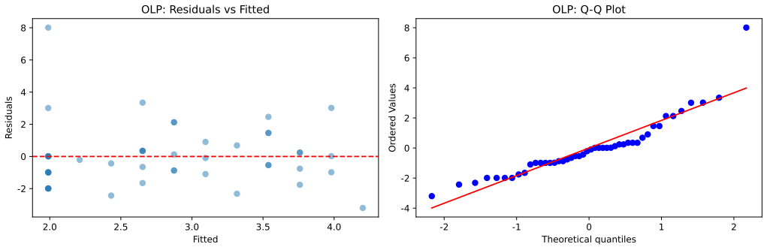
Supplementary Fig. 1. Regression diagnostic plots for the OLP multiple regression model (Table 5). Left panel: Residuals vs. fitted values plot to assess homoscedasticity; the random scatter around the horizontal line at zero indicates acceptable homoscedasticity. Right panel: Q-Q (quantile-quantile) plot to assess normality of residuals; points closely following the diagonal line indicate approximately normal distribution. One potential influential case was identified but remained within acceptable thresholds (Cook’s distance <0.1). OLP: oral lichen planus.

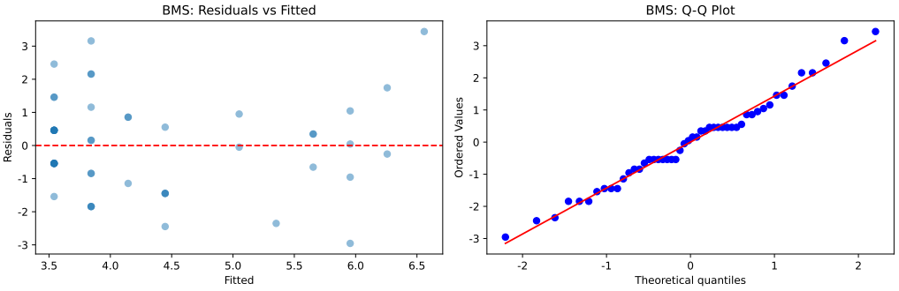
Supplementary Fig. 2. Regression diagnostic plots for the BMS multiple regression model (Table 6). Left panel: Residuals vs. fitted values plot showing acceptable homoscedasticity with no clear pattern in residual distribution. Right panel: Q-Q plot indicating approximately normal distribution of residuals. Three potential influential cases were identified but remained within acceptable thresholds (Cook’s distance <0.3), confirming model validity. BMS: burning mouth syndrome; Q-Q plot: quantile-quantile plot.

Supplementary Table 5. Spearman correlation matrix for the OLP group.
 | Worst | Least | Average | Current | Activity | Mood | Mastication | Work | Relation | Sleep | Enjoyment
Worst | 1.00 | 0.37 | 0.55 | 0.48 | 0.44 | 0.59 | 0.55 | 0.49 | 0.44 | 0.19 | 0.40
Least | 0.37 | 1.00 | 0.51 | 0.74 | 0.43 | 0.27 | 0.44 | 0.46 | 0.41 | 0.44 | 0.28
Average | 0.55 | 0.51 | 1.00 | 0.62 | 0.32 | 0.42 | 0.49 | 0.37 | 0.37 | 0.25 | 0.31
Current | 0.48 | 0.74 | 0.62 | 1.00 | 0.50 | 0.38 | 0.60 | 0.56 | 0.56 | 0.39 | 0.45
Activity | 0.44 | 0.43 | 0.32 | 0.50 | 1.00 | 0.57 | 0.62 | 0.77 | 0.66 | 0.65 | 0.65
Mood | 0.59 | 0.27 | 0.42 | 0.38 | 0.57 | 1.00 | 0.61 | 0.47 | 0.57 | 0.38 | 0.63
Walking | 0.55 | 0.44 | 0.49 | 0.60 | 0.62 | 0.61 | 1.00 | 0.75 | 0.61 | 0.60 | 0.55
Work | 0.49 | 0.46 | 0.37 | 0.56 | 0.77 | 0.47 | 0.75 | 1.00 | 0.69 | 0.76 | 0.47
Relation | 0.44 | 0.41 | 0.37 | 0.56 | 0.66 | 0.57 | 0.61 | 0.69 | 1.00 | 0.62 | 0.60
Sleep | 0.19 | 0.44 | 0.25 | 0.39 | 0.65 | 0.38 | 0.60 | 0.76 | 0.62 | 1.00 | 0.54
Enjoyment | 0.40 | 0.28 | 0.31 | 0.45 | 0.65 | 0.63 | 0.55 | 0.47 | 0.60 | 0.54 | 1.00
The matrix displays correlations among pain severity measures (worst, least, average, current) and pain interference domains (activity, mood, walking/mastication, work, relationships, sleep, enjoyment). Correlations with |r| > 0.5 are considered strong and indicate substantial inter-relationships among pain interference domains. Visual representation is provided in Supplementary Fig. 3.

Supplementary Table 6. Spearman correlation matrix for the BMS group. The matrix displays correlations among pain severity measures (worst, least, average, current) and pain interference domains (activity, mood, walking/mastication, work, relationships, sleep, enjoyment).
 | Worst | Least | Average | Current | Activity | Mood | Mastication | Work | Relation | Sleep | Enjoyment
Worst | 1.00 | 0.36 | 0.73 | 0.49 | 0.24 | 0.41 | 0.15 | 0.12 | 0.34 | 0.27 | 0.48
Least | 0.36 | 1.00 | 0.46 | 0.51 | 0.14 | 0.13 | 0.09 | 0.12 | 0.23 | 0.03 | 0.29
Average | 0.73 | 0.46 | 1.00 | 0.78 | 0.27 | 0.40 | 0.18 | 0.08 | 0.33 | 0.40 | 0.38
Current | 0.49 | 0.51 | 0.78 | 1.00 | 0.22 | 0.22 | 0.06 | 0.06 | 0.37 | 0.33 | 0.40
Activity | 0.24 | 0.14 | 0.27 | 0.22 | 1.00 | 0.17 | 0.41 | 0.53 | 0.38 | 0.32 | 0.24
Mood | 0.41 | 0.13 | 0.40 | 0.22 | 0.17 | 1.00 | 0.22 | 0.22 | 0.39 | 0.21 | 0.63
Walking | 0.15 | 0.09 | 0.18 | 0.06 | 0.41 | 0.22 | 1.00 | 0.66 | 0.34 | 0.32 | 0.09
Work | 0.12 | 0.12 | 0.08 | 0.06 | 0.53 | 0.22 | 0.66 | 1.00 | 0.41 | 0.20 | 0.08
Relation | 0.34 | 0.23 | 0.33 | 0.37 | 0.38 | 0.39 | 0.34 | 0.41 | 1.00 | 0.11 | 0.47
Sleep | 0.27 | 0.03 | 0.40 | 0.33 | 0.32 | 0.21 | 0.32 | 0.20 | 0.11 | 1.00 | 0.26
Enjoyment | 0.48 | 0.29 | 0.38 | 0.40 | 0.24 | 0.63 | 0.09 | 0.08 | 0.47 | 0.26 | 1.00
Fewer strong correlations (|r| > 0.5) were observed compared to the OLP group, suggesting more focal impact of pain. Visual representation is provided in Supplementary Fig. 4.

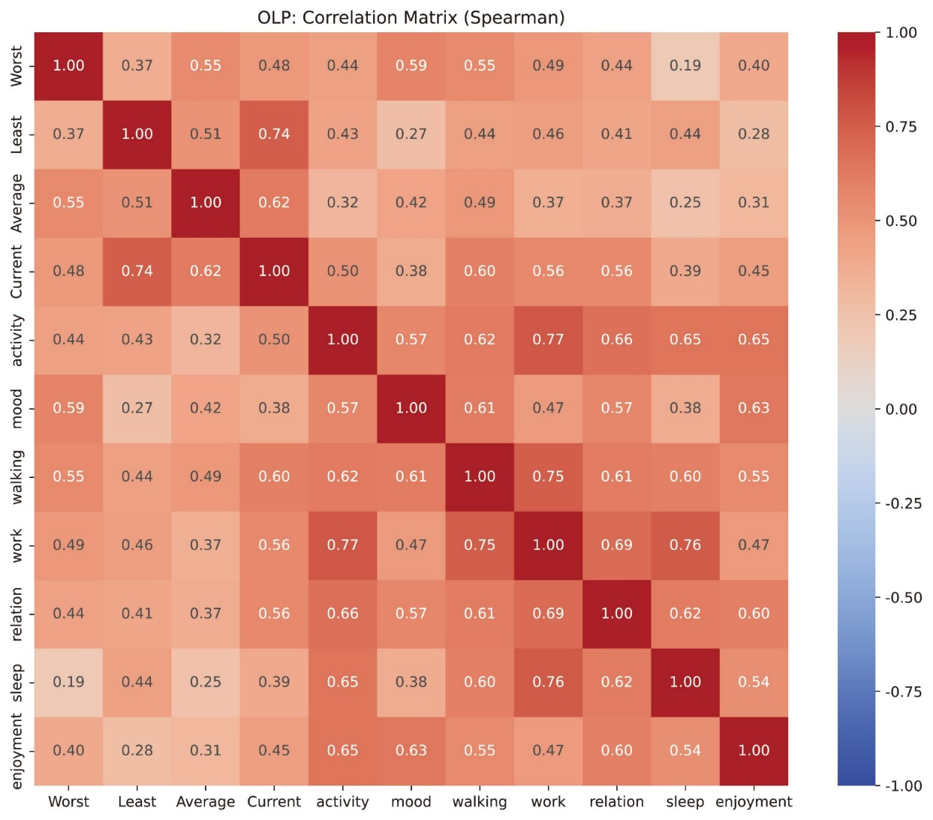
Supplementary Fig. 3. Correlation heatmap for the OLP group. Visual representation of the Spearman correlation matrix (Supplementary Table 5) displaying relationships among pain variables. Color intensity indicates correlation strength: red for positive correlations, blue for negative correlations, with darker colors representing stronger correlations. The extensive network of strong correlations (|r| > 0.5) demonstrates the pervasive impact of pain across multiple life domains in OLP patients. OLP: oral lichen planus.

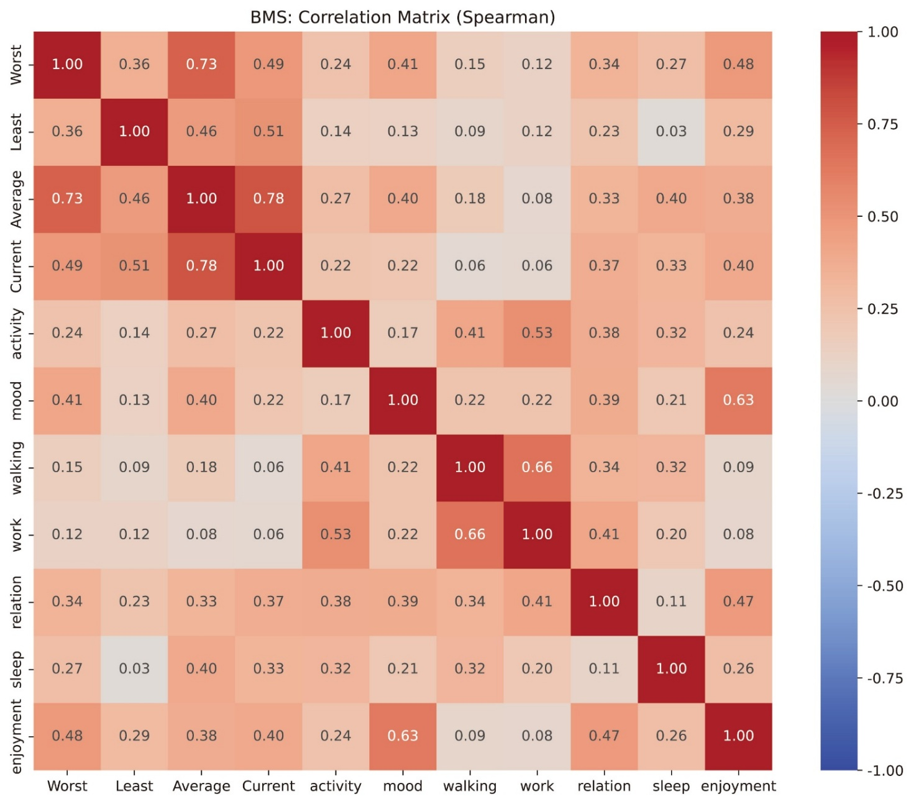
Supplementary Fig. 4. Correlation heatmap for the BMS group. Visual representation of the Spearman correlation matrix (Supplementary Table 6) displaying relationships among pain variables. Color scheme is identical to Supplementary Fig. 3. The sparser pattern of strong correlations compared to Supplementary Fig. 3 indicates more focal impact of pain in BMS despite higher pain intensity, possibly reflecting the neuropathic nature of pain without visible pathology. BMS: burning mouth syndrome.

